caArray
Configuration Management Plan

Last Revised: | February 25, 2008
Produced By: | CBIIT Development Team
Version: | 0.8

Document Approvals
The list contains the name for the core project team and any key stakeholders who have an interest in the success of the project. An “S” identifies persons responsible for approval from the Business and Development. Sign off of the document would be required when a decision is made not to take action for defined gaps.

S | Name | Role | S | Name | Role
S | Anand Basu | CBIIT Engineering Manager | S | Juli Klemm, Ph.D. | Product Manager
 | Brent Gendleman | Development Project Manager |  | Jerry Eads | CBIIT Project Manager
 | Eric Tavela | Development Architect |  | George Komatsoulis | CBIIT Independent QA
 | Don Swan | CBIIT Application Support
Revision History
When you make a change to a document, you must add an entry to this Revision History table and you must manually type the Last Revised Date on the front cover.
Date | Version | Description | Revised by
4/3/07 | 0.1 | Initial Draft | Brent Gendleman
5/5/07 | 0.2 | Updated | Eric Tavela
5/16/07 | 0.3 | Completed for Review post 5/15 CCM meeting concern procedures for 1.5x | Brent Gendleman
9/28/07 | 0.4 | Updated Defect Tracking Process | Brent Gendleman
10/1/07 | 0.5 | Included depiction of attribution for defects in the tracker – prepared for review by Ron | Brent Gendleman
10/2/07 | 0.6 | Revised model, made an unaddressed issue section after review with Ron Keene | Brent Gendleman
1/3/08 | 0.7 | Revised per developer process change for indicating code complete in GForge prior to testing on dev environment | Brent Gendleman
2/25/08 | 0.8 | Revised to reflect defect tracking process changes, particularly scheduling and prioritization | Brent Gendleman

Table of Contents
1. Introduction 1
1.1. Purpose 1
1.2. Scope 1
1.3. Definitions, Acronyms, and Abbreviations 1
1.4. References 1
1.5. Overview 2
1.6. Unaddressed Issues 2
2. Software Configuration Management 2
2.1. Organization, Responsibilities, and Interfaces 2
2.2. Tools, Environment, and Infrastructure 2
3. The Configuration Management Program 3
3.1. Configuration Identification 3
3.1.1. Identification Methods 3
3.1.2. Project Baselines 5
3.2. Configuration and Change Control 5
3.2.1. Change Request States 6
3.2.2. Feature Requests 8
3.2.3. Defect Management 9
3.3. Configuration Status Accounting 13
3.3.1. Project Media Storage and Release Process 13
3.3.2. Reports and Audits 13
4. Milestones 13
5. Training and Resources 13
6. Subcontractor and Vendor Software Control 14

Introduction

Purpose
This document describes the approach to be used for configuration and change management for the caArray project.

Scope
This document covers all aspects of configuration and change management including tools, conventions and policies. This document covers both internal and external (client interface) requirements for change and configuration management.

Definitions, Acronyms, and Abbreviations
CCG – Change Control Group
GA – General Availability
LOE – Level of Effort
SCM – Software Configuration Management
SVN - Subversion

References
[CR-MDL] Change Request Model
//cm/caarray2/docs/configuration_and_change_management/models/caarray2_change_control_model.eap
Rational Unified Process, version 2003.06.15
The Requirements Management Plan
https://gforge.nci.nih.gov/svnroot/caarray2/trunk/docs/requirements/caarray_requirements_management_plan.doc
Development Test Plan: https://gforge.nci.nih.gov/svnroot/caarray2/trunk/docs/test/caarray_test_plan.doc
Independent Quality Assurance Test Plan
TO BE ENTERED
CBIIT Remote Deploy Developer
https://gforge.nci.nih.gov/svnroot/caarray2/trunk/docs/deployment/auto-remote-deploy/ncicb-remote-deploy-developer.doc

Overview
Section 2 of this document covers details of the software configuration management (SCM) and change request tracking systems and their contexts. Section 3 covers the policies and process to be followed for configuration management, change management, and configuration status accounting. Section 4 defines key events in the CM lifecycle. Section 5 details how the CM tools and processes will be supported. The last section, Section 6 describes how the caArray project will handle potential changes to third-party software.

Unaddressed Issues
All currently addressed.

Software Configuration Management

Organization, Responsibilities, and Interfaces
The development team is responsible for configuration management on the NCIA System projects and for structuring and managing the change request process using GForge (described below).
The CBIIT Systems Team is responsible for providing and maintaining the Subversion (SVN) server and GForge server to be used for change management. Support for these tools is provided by contacts at the CBIIT that can be found at the CBIIT Application Support Group web page (http://ncicbsupport.nci.nih.gov/sw/). CBIIT is also fundamentally responsible for all change management decisions, though decisions will be discussed in a Change Control Meeting (CCM) composed of stakeholder representatives from the various internal teams.

Tools, Environment, and Infrastructure
SVN will be employed as the SCM server. As mentioned previously, the server is maintained by CBIIT. The Subversion URL that should be used to access the server is https://gforge.nci.nih.gov/svnroot/caarray2/trunk. 5AM will use the Subversion client from tigris.org, TortoiseSVN and the Subclipse Eclipse plug-in for client access.
5AM, CBIIT and the other caArray project stakeholders such as the Project and Product Manager and Independent Quality Assurance (IQA) will use GForge Tracker for change request management. The caArray GForge project site may be found at http://gforge.nci.nih.gov/projects/caArray 2.0.

The Configuration Management Program

Configuration Identification

Identification Methods
Artifact Names: Artifacts should generally be named according to the following scheme:
caarray_<full name of artifact>.<file extension> (all lower case).
As an example, this document’s filename is caarray_configuration_management_plan.doc.
The exceptions to this scheme are things such as Java source code where the standard convention is something else (in the case of Java, camel case). Also any third party resources that are under CM should retain their original names.
Artifact Identifiers: To uniquely identify project artifacts, use the following scheme:
//cm/caarray2/<directory path to artifact>/<artifact file name>.
“//cm/” is meant to represent the root of the CM repository. This name was chosen over SVN (current CM system) in order to remain technology agnostic. As an example, this document’s artifact identifier is:
//cm/caarray2/docs/configuration_and_change_management/caarray_configuration_management_plan.doc
Each document that has the capability for footers will include the artifact identifier in the footer.
Baseline Names: Baseline names will follow the scheme given in the RUP under the activity Establish Configuration Management Policies with the following exceptions:
“.” characters will be replaced by underscores.
Iteration milestone baselines will have an iteration identifier appended to the end of the baseline name as follows:
<initial of phase, capitalized><number of iteration within phase>
For example, the baseline created at the end of the second Elaboration iteration for caArray 2.0 would be CAARRAY_R2_0_0_E2.
Baselines delivered to QA will be labeled with the release, QA and an ascending integer, e.g. CAARRAY_R2_0_0_QA1
Release candidate baselines will be labeled with the release, RC and an ascending integer, e.g.. CAARRAY_R2_0_0_RC1.
General availability baselines will be labeled CAARRAY_R2_0_0_GA.
Internal baseline names will consist of the project tag followed by an underscore followed by “BL” another underscore and the baseline number (independent of release version). These baselines are generated by the continuous integration platform as artifacts are checked in and the various unit tests and quality checks pass.
Generally most baselines will be internal baselines across the entire system. As an example the 27th build during the development of caArray 2.0 would be CAARRAY_BL_27.
Note that many baselines may have multiple labels, for instance the baseline labeled CAARRAY_BL_123 may be given the additional label CAARRAY_R2_0_QA_4 when promoted to QA. The same holds true for promotion of a baseline from QA to release candidate to GA.
Product Directory Structure: The directory structure should follow the structure given below which is generally based on the guidelines given in the RUP .

Project Directory Structure:
/docs
/analysis_and_design
/models
/references
/reviews
/configuration_and_change_management
/models
/references
/deployment
/auto-remote-deploy
/references
/end_user_documentation
/final
/working_copies
/environment
/references
/implementation
/references
/project_management
/internal_meetings
/open_meetings
/references
/reports
/requirements
/models
/references
/reports
/use_cases
/user_interface
/templates
/test
/models
/results
/software
/build
/resources
/site
/lib
/<component_1_name>
…
/<component_n_name>
/test-data
/src
/test
/data
/java
Component Directory Structure:
/<component_name>
/src
/main
/java
/webapp (for .WARs only)
/test
/java
/target
/classes
/instrumented-classes (classes with special code coverage checking properties)
/test-classes
/junit (Unit test results)

Project Baselines
Project baselines for internal releases will be automatically created and labeled as part of the continuous integration approach used by 5AM. A baseline will also be created at the end of each iteration. Baselines will contain the entire contents of the CM repository for the project.

Configuration and Change Control
At the most fundamental level, there are three types of change requests – feature requests, defects and change orders. Change requests are artifacts of the interaction between the stakeholder community and the product team where either the scope of what is available or the evaluation of what has been provided is in potential conflict with the stakeholder needs. Change Requests will be used as the foundation for managing the project’s activities and communication with regard to defects and features and as such, distinct trackers will be set up in G-Forge for each.
Feature requests indicate a desire from anyone in the stakeholder community to submit features for consideration by the caArray Change Control Group (CCB) that are unmet by any of the existing features, supplemental requirements or use cases. Defects represent a suggestion by the stakeholder community that an agreed upon piece of functionality does not work as advertised.
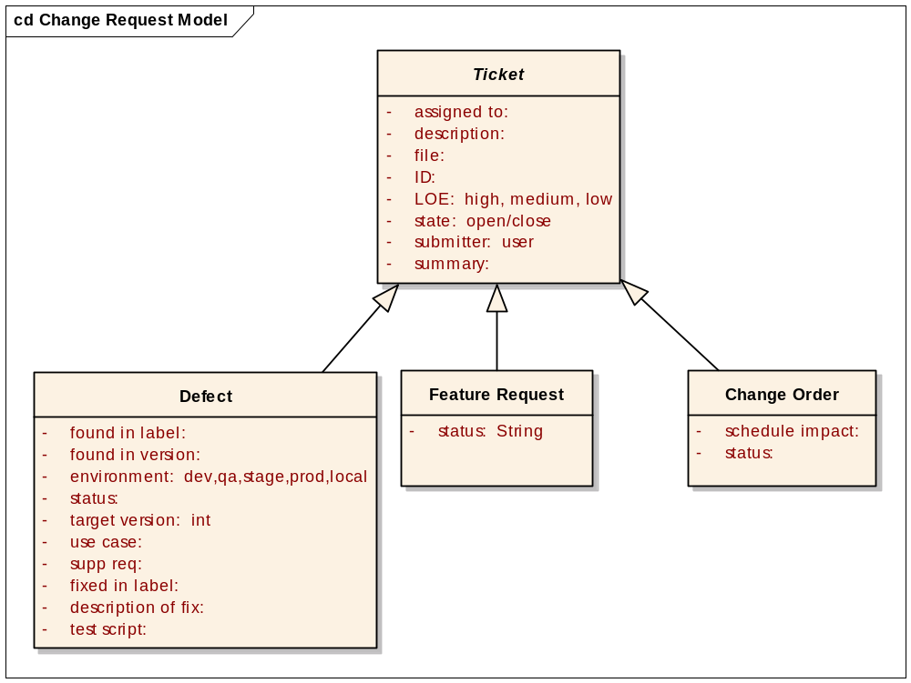
Figure 1 Basic Change Request Model
As mentioned above, these two artifact types carry significant weight into the successful management of the project by supporting the awareness and directed activity that what is being delivered meets the explicit needs of the stakeholders. These change request types share some attribution but have fundamentally different procedural paths. The upcoming subsections will describe both their shared components and the individual attributes and workflows.

Change Request States
The states a Change Request can transition through are depicted in Figure 2 and described in the following table. A balance between the level of manual data entry and the benefit having the data available in G-Forge is being struck in favor of a level of granularity that allows for unconnected stakeholders in the day to day to tactically be aware of the state of any CR.
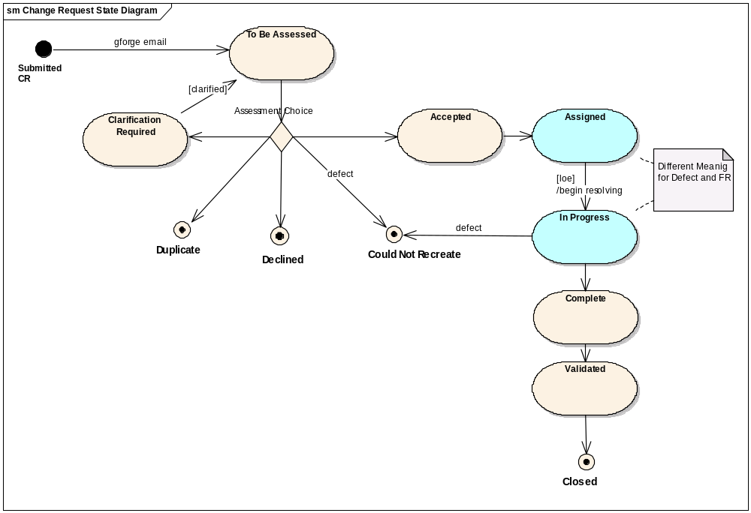
Figure 2 Change Request States
The state definitions are detailed in Table 1. As noted in Figure 2, the “assigned” and “in progress” state is different depending on whether it is a Feature Request or a Defect.

Table 1 Change Request State Definitions
State | Definition | Access Control
Submitted CR | This state occurs as the result of 1) a new Change Request submission, 2) an update of an existing Change Request or 3) consideration of a Declined Change Request for a new release cycle. Change Request is placed in the CCM Review queue to be dealt with by the Project Manager. No owner assignment takes place as a result of this action. | All Users
To Be Assessed | Upon receiving notification of the submitted CR, the Project Manager may update the CR to this state. The PM reviews the CR and determines whether an immediate transition can occur, further assessment is required or if additional information is needed. If additional information is needed, the PM will change the assignment of the CR to the development team member. Once the Project Manager verifies the validity of the change request, they may choose to call an emergency CCM Review Meeting to determine if priorities need to change. | Project Manager  Development
Duplicate | A Change Request in this final state is determined to be a duplicate of a previously submitted Change Request. Change Requests can be put into this state by the PM or by the team member assigned to resolve it. When the Change Request is placed into the Duplicate state, the Change Request number it duplicates will be recorded. A submitter should initially query the Change Request database for duplicates of a Change Request before it is submitted. This will prevent several steps of the review process and therefore save a lot of time. | Project Manager  IQA Manager  Development
Declined | The Change Request is determined to be valid, but "out of scope" for the current release(s). Change Requests in the Declined state will be held and reconsidered for future releases. A target release may be assigned to indicate the timeframe in which the Change Request may be Submitted to re-enter the CCM Review queue. This may be influenced based on the assessment’s LOE as well. | Product Manager  Project Manager
Clarification Required | Insufficient data exists to confirm the validity of a Reject or Duplicate Change Request. The owner automatically gets changed to the submitter who is notified to provide more data. | Project Manager
Accepted | The Change Request is acknowledged as a valid CR whose LOE is understood and will be placed into the queue for assignment. While it is understood the assignment may happen immediately, this state allows for the acknowledgement alone. For FR, this is the transition point where it becomes a Feature. | Project Manager  Product Manager
Assigned | The CR is assigned to a development team member, placed into the Project Plan and in the case of a FR, assigned a target release, and related to an existing use case or supplemental requirement (or kick off a new one to be created). | Project Manager  Product Manager  Development
In Progress | Indicates that work has actively begun on the CR, either because of new development or maintenance activities. | Development
Coding Complete | Indicates that a developer has committed code to CM and run through integration but prior to testing on external (dev) environment | Development
Complete or Fixed (defect) | Signifies that the resolution of this Change Request is complete and is available for validation. | Project Manager  Development Manager
Validated | A Change Request in this state has been Verified by IQA in a test build and is ready to be included in a release. | IQA
Closed | Change Request no longer requires attention. This is the final state a Change Request can be assigned. Only the Product or Project Manager has the authority to close a Change Request. When a Change Request is Closed, the submitter will receive an email notification with the final disposition of the Change Request. | IQA

Feature Requests
By the close of Inception, the feature set will be established for caArray. However, requirements, particularly features, are not static and the feature request process is established to support the evolution of the system and keeping in synch with the needs of the user community.

Feature Request Workflow
The workflow is described in the activity diagram depicted in Figure 3.
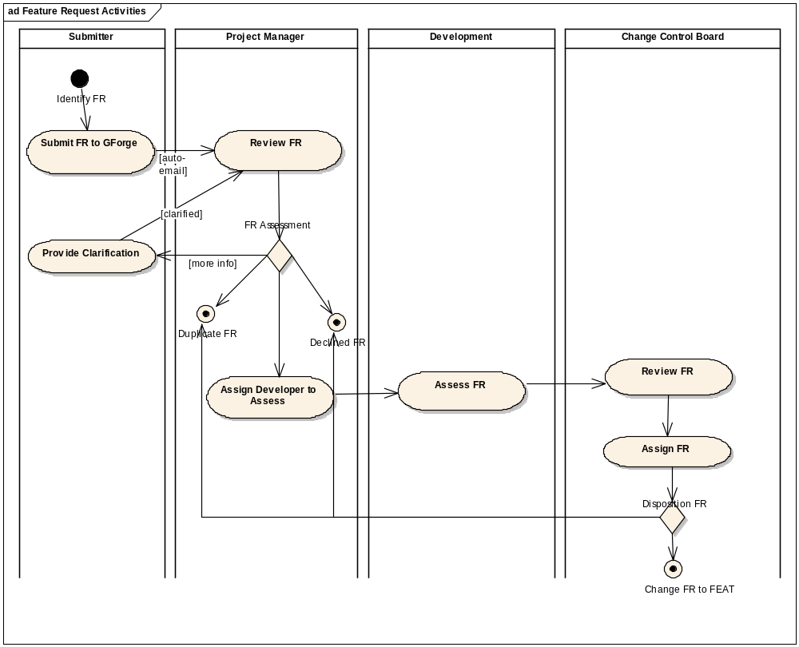
Figure 3 Feature Request Activity diagram

Defect Management
The process for defect management evolves at different stages in the overall development lifecycle and is dependent on the overall test strategy being employed by both the Development Team and Independent Quality Assurance. The Development team primarily focuses on Unit and Integration Testing while Independent QA focuses on Functional and Performance Testing.
The Development Team will not record defects found in the GForge Tracker in the early stages of development. However, once an Alpha release is provided, a Development Team Member may enter a defect against a feature previously delivered to support the overall goal of quality. In addition, the Development Team has established Continuous Integration of every code change, tools for automating the reporting of unit test failures, code coverage and performance testing and voluntarily placed the burden of delivering a build that doesn’t fail those tests before a tag can be delivered to QA.
The QA Team will be the primary submitter of defects. When submitting a defect, the attributes in Figure 4 taken from the general model will be entered into GForge
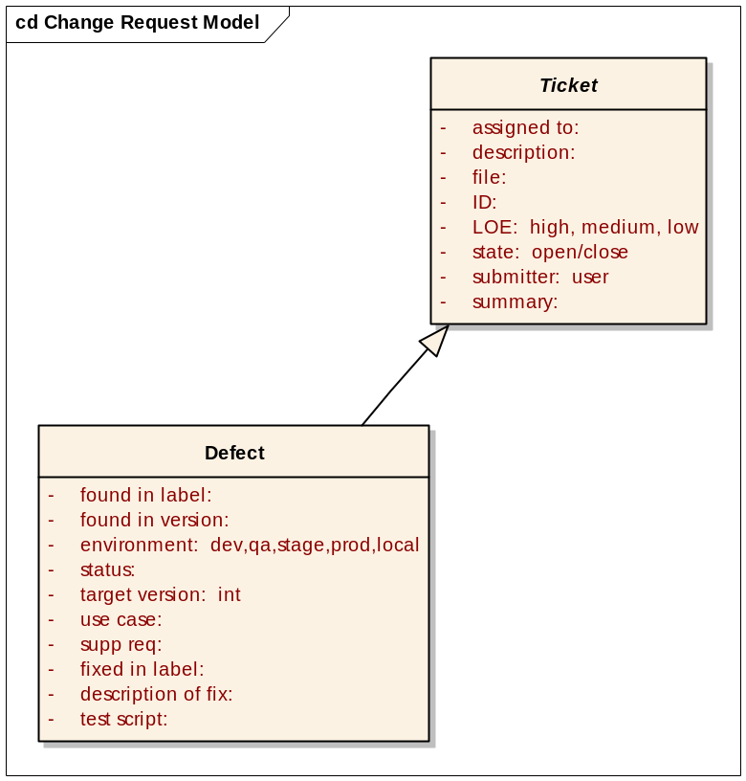
Figure 4. Defect Attributes
It is understood that when external users are the submitters of the defect, all of the attribution may not be known to them – in particular the association of the appropriate use case or supplemental requirement. The QA and Development team will perform the initial review to ensure that as much of the appropriate data is available to the CCG for decision making. The workflow each defect will go through is described in the workflow section below.
Tool Note: The ability to share custom lists in GForge is limited. The desire will be to eventually allow for lists created across trackers to be referenced but it anticipated for the 2.0 release that the lists (those that are created via the “manage custom fields” capabilities such as use cases and supplemental specifications) will have to be copied by hand. The benefit for going through the process is to allow for traceability and overall management of the software to be greatly increased; the drawback is the amount of manual maintenance effort to support distinct lists.
In addition, all of the fields that are available for any Change Request Artifact are also available for the Defect (see Figure 4 for an isolated depiction). The most significant will be the assignment of individuals to defects, which will change according to the activity diagram (see Figure 5) in terms of who an item is assigned to (when a defect is in development, a developer will be assigned; when in QA, a tester will be assigned).

Table 2 - Defect GForge Attribution
Attribute | Definition | Representative List
Found in Label | Describes the tag of the build where the defect was first identified | CAARRAY_R2_0_0_C2A1  CAARRAY_R2_0_0_C2B1  CAARRAY_R2_0_0_C3B2
Found in Version | Describes the version of the software that the defect was first found against (see RMP) | 2.0, 2.0.1, 2.1, etc.
Environment | Describes the server environment where the defect was first found | Dev, QA, Stage, Prod, Local
Status | Description of the state of effort against the defect (see Table 1) | Accepted, Assigned, etc.
Target Version | The version of the software where the fix is expected by the CCG to be available (see RMP) | 2.0, 2.0.1, 2.1, 2.2, deferred, etc.
Use Case | The use case title(s) that most accurately reflect the activity attempting to be executed | Acquire_Experiment_Data_Via_API  Download Data, etc.
Supp Req | The supplemental requirement title(s) that most accurately affect the non-functional or global requirement | Ability to be included in LSD bundle  Validate Required Fields  Page Loading Indicator
Fixed in Label | The tag that the fix for the defect has been included in for validation | CAARRAY_R2_0_0_C2B1  CAARRAY_R2_0_0_C3B2
Description of Fix | A textual depiction of what was done to address the defect | Text
Test Script | The name of the test script that executes the fix of the defect, usually specific to a use case if possible | LoginBasicFlowTest  ImportStandardMageTabSetTest
LOE | Level of effort to complete the work (use case and documentation assessment, fixing the defect, testing the defect)
Release Notes | An indicator of whether a defect that is deferred from an upcoming release needs to be included in the release notes | Trivial, low, medium, high

Workflow
For each defect that is identified in GForge, the following activity diagram describes the process for addressing the defect.
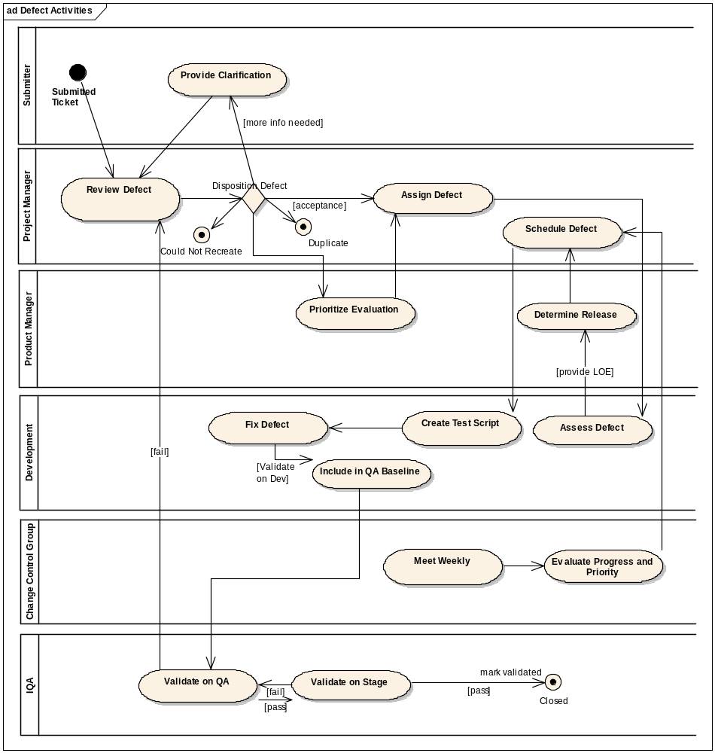
Figure 5. Defect Management Process
The Project Manager is a key actor in the process described in Figure 5. The initial review of the defect will be to ensure that as much data can be gleamed from the submitter as possible, including outreach to acquire clarification. On occasion, the Project Manager may need to seek the counsel of the Product Manager for determining whether a defect should be evaluated. Otherwise, the Project Manager can assign the defect for evaluation and schedule the defect. Weekly prioritizations of defects will occur by the CCG and may cause a schedule change.
2.0 raises some unique challenges in that software product is not a natural evolution but a new “generation”. From the User Interface to the functional capabilities, the software is radically going to change. Once the initial alpha is released, Defects will be entered in the Defect Tracker. Time will be allocated to fix prioritized defects in time for the initial release of Beta, or the CCG may choose to defer those fixes to the second Beta Release, the GA release or deferred altogether from the 2.0 release. Those same decisions will be made going forward following the more established model of caBIG™ with the reference point being minor (2.0.1) or major releases (2.1). A minor release has no impact to the data model (and therefore the grid and potentially CDEs) and is primarily viewed as a defect release. A major release may impact the data model and typically will focus on a new set of features in addition to defect fixes.

Configuration Status Accounting

Project Media Storage and Release Process
All project artifacts will be stored in SVN. When the final release candidate passes QA and user acceptance testing, this release (in both binary and source formats) will be posted to the Files tab of the caArray GForge site and to the caArray public distribution web site.

Reports and Audits
CM reports (such as defect aging, outstanding issues, etc.) will be created on an as needed basis using the tools available in GForge and Microsoft Excel.

Milestones
The major CM milestones include the following events:
  - Releasing iteration boundary baselines
  - Releasing a baseline to QA; typically the first will be an iteration baseline, but there may be subsequent baselines promoted if blocking defects are uncovered and during the end of the construction phase.
  - Delivering Alpha and Beta baselines
  - Delivering release candidate baselines
  - Promoting a release candidate baseline to General Availability (GA).

Training and Resources
No formal training is expected to be necessary for use of the change and configuration management supporting tools. 5AM will present to the various stakeholders that use the change management trackers in GForge how the process should work and will make available the Microsoft PowerPoint presentation used. 5AM will informally provide support for the change management process to ensure that it remains smooth.

Subcontractor and Vendor Software Control
Third-party libraries and tools that are incorporated into caArray will be added directly into the CM repository and incorporated in the build process to ensure stability. For any required software that is not part of the distribution (e.g. web browsers, JBoss, MySQL), the supported types and versions will be clearly documented in the installation and/or users’ guide.

